# Using the L5X rung export file with In-Sight IS2800

A file named “InSight2800_CopyRung.L5X” contained in this folder can be used to streamline use of an In-Sight IS2800 platform in RSLogix 5000. Before using this file, the EDS files included with the release should be imported into RSLinx using the EDS Hardware Installation tool that comes with RSLinx.

To connect your In-Sight IS2800 to RSLogix, first add a connection to your Ethernet Communications Card by selecting the “New Module…” menu item after right-clicking on the Ethernet node in the I/O configuration folder:

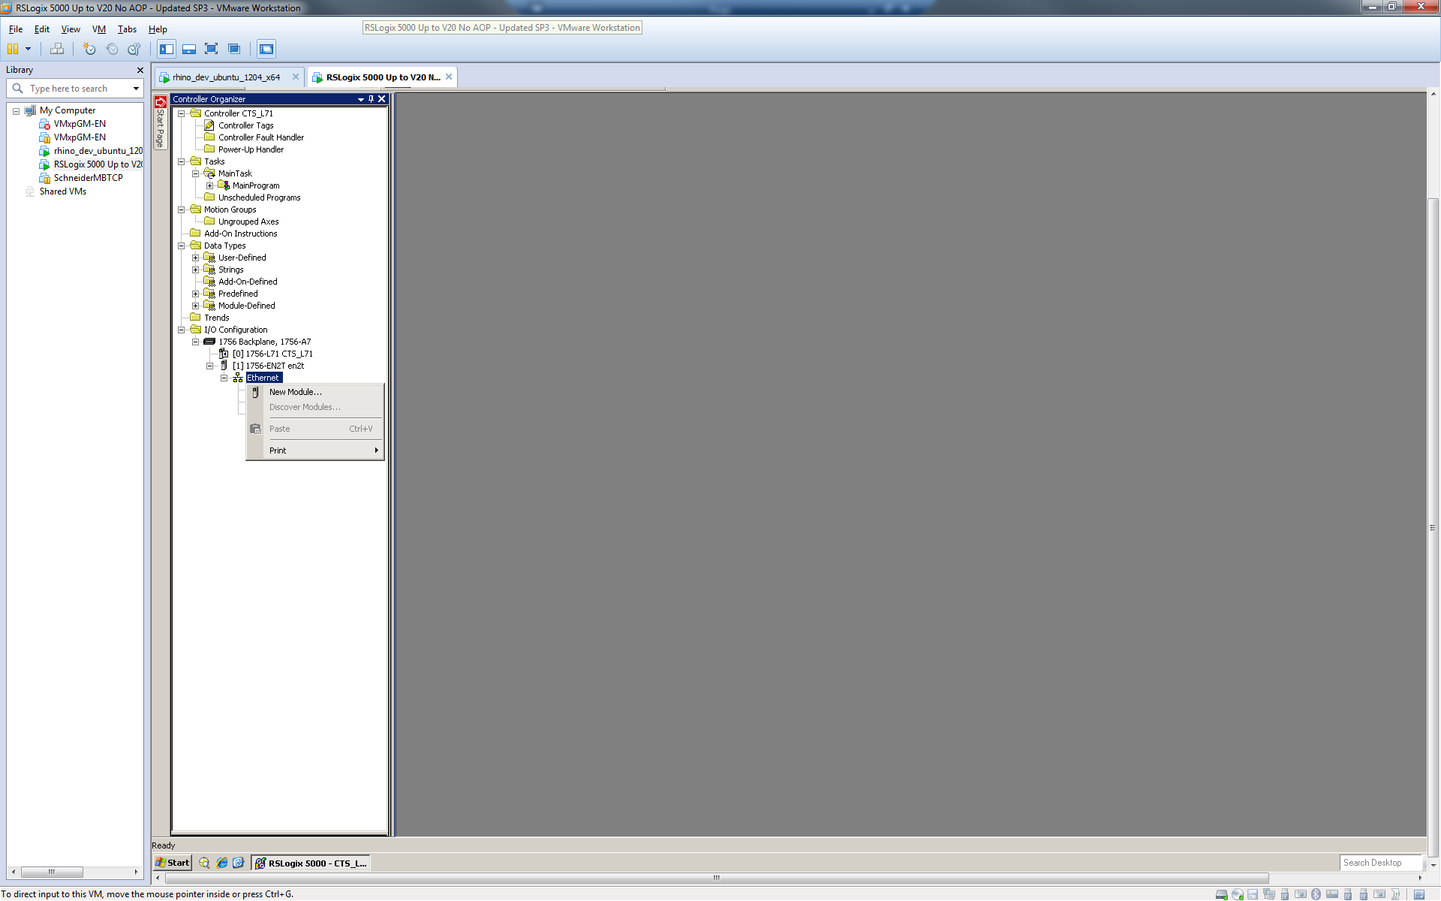

It’s important to note that after loading the new EDS files, new module types will show up and the appropriate module should be selected. Use of the “*Generic Module*” is discouraged.

In the “New Module” dialog, enter the In-Sight System’s name and IP Address, then click the “Change…” button to setup the size of the connection:

After adding the In-Sight to the RS Logix project, you can use the L5X rung import file to create structured data for the connection. In your main program, right-click on an empty rung and select the “Import Rungs…” menu item, then select the InSight2800_CopyRung.L5X file installed with In-Sight Vision Suite, and push the “Import…” button.

Click on the “Tags” node in the content tree to change the names of the created tags to match your configuration. Make sure you set the names of InSight_1:I1 and InSight_1:O1 tags to the connection controller tags in your project that match the name given to the In-Sight connection above.

After pressing OK, a rung will be added to your project which includes copy instructions to copy the data between your generic connection data and the structured data types included in the rung import file.

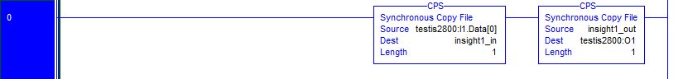

When writing your ladder program, reference the elements in the structured data variables; the copy rung above will automatically move the data to and from the structured data instances to the EtherNet/IP connection. *Download and run* to get the tags to copy data initially, otherwise an array of SINTS will be all that is seen.